#1. Calculating Volatility of all 3 stocks.

By Defn: Volatility is the degree of variation of a trading prices over series of a time.

#Formula : Avg(High - Low)

Select symbol, round(avg(high - low),2) as avg_volatility,

dense_rank() over(order by avg(high - low))

as ranking from A1

where symbol <>'BHARTI'

group by symbol;

Output: Bharti Airtel has the least volatility and Maruti Suzuki has higher volatility.  
  
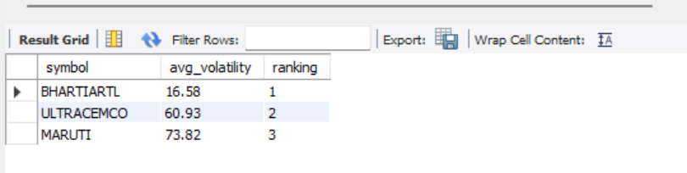

2. Calculating drawdown/ fall in stock price.

A drawdown refers to how much an investment or trading account is down from the peak before it recovers back to the peak.  
  
Formula: (Final Value – Initial Value)/Initial Value * 100

#2. Calculating the drawdown/ fall in stock price

/* A. Calculating for Bharti_Airtel Stock Price */

set @pre_covid_bha_artl_price:=(Select close from bharti_airtel where date='2020-03-20');

set @post_covid_bha_artl_price:=(Select close from bharti_airtel where date='2020-03-23');

Select @pre_covid_bha_artl_price;

Select @post_covid_bha_artl_price;

Select round(((-@pre_covid_bha_artl_price+@post_covid_bha_artl_price)/@pre_covid_bha_artl_price),5)* 100 as Bharti_Airtel_DrawDown;

/* B. Calculating for Maruti_Suzuki Stock Price */

set @pre_covid_mar_suz_price:=(Select close from maruti_suzuki where date='2020-03-20');

set @post_covid_mar_suz_price:=(Select close from maruti_suzuki where date='2020-03-23');

Select @pre_covid_mar_suz_price;

Select @post_covid_mar_suz_price;

Select round(((-@pre_covid_mar_suz_price+@post_covid_mar_suz_price)/@pre_covid_mar_suz_price),5)* 100 as Maruti_Suzuki_DrawDown;

/* C. Calculating for Ultra Cement Stock Price */

set @pre_covid_ult_cem_price:=(Select close from ultra_cemco where date='2020-03-20');

set @post_covid_ult_cem_price:=(Select close from ultra_cemco where date='2020-03-23');

Select @pre_covid_ult_cem_price;

Select @post_covid_ult_cem_price;

Select round(((-@pre_covid_ult_cem_price+@post_covid_ult_cem_price)/@pre_covid_ult_cem_price),5)* 100 as Ultra_Cement_DrawDown;

Select round(((-@pre_covid_bha_artl_price+@post_covid_bha_artl_price)/@pre_covid_bha_artl_price),5)* 100 as Bharti_Airtel_DrawDown

union

Select round(((-@pre_covid_mar_suz_price+@post_covid_mar_suz_price)/@pre_covid_mar_suz_price),5)* 100 as Maruti_Suzuki_DrawDown

union

Select round(((-@pre_covid_ult_cem_price+@post_covid_ult_cem_price)/@pre_covid_ult_cem_price),5)* 100 as Ultra_Cement_DrawDown;

Output: Bharti Airtel has least drawdown, and Maruti Suzuki has most drawdown

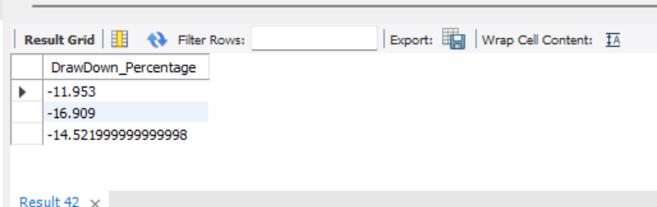

3. Finding recovery days as number of days taken by stock to close above it’s pre-covid price.

set @date_close_more_than_precovid_maruti:=

(Select date from

(Select date, close, row_number() over(order by date) as rank_based_on_date from maruti_suzuki

where date between '2020-03-23' and '2021-04-30' and close>=@pre_covid_mar_suz_price) as A3

where rank_based_on_date =1);

select @date_close_more_than_precovid_maruti;

select timestampdiff(day,"2020-03-23", @date_close_more_than_precovid_maruti)

as num_of_days_taken;

Output: No. of days taken by Maruti Suzuki stock to cross its precovid close price  
  
  
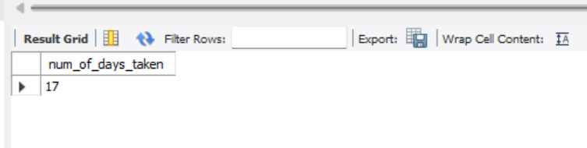  
  
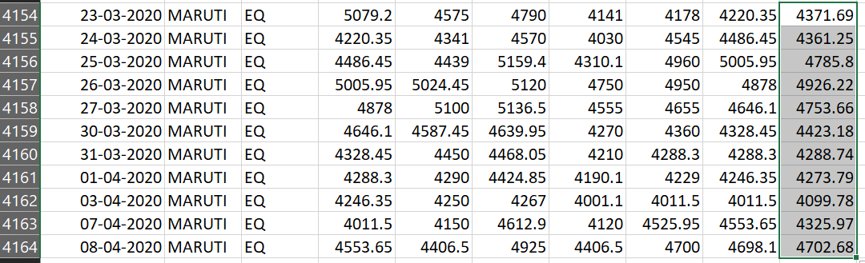

#4. Number of days when stock price closed above its previous day closed price

Drop view A2;

create view A2 as (Select symbol, date, close from bharti_airtel

union

Select symbol, date, close from maruti_suzuki

union

Select symbol, date, close from ultra_cemco);

Select * from A2;

Select symbol, sum(if((close>prev_day_CC),1,0)) as num_of_days_above_prev_close,

dense_rank() over(order by sum(if((close>prev_day_CC),1,0)) desc) as rank_prev_close from

(select symbol, date, close, lag(close) over(partition by symbol order by date) as prev_day_cc from A2) as xyz group by symbol;

Output:   
  
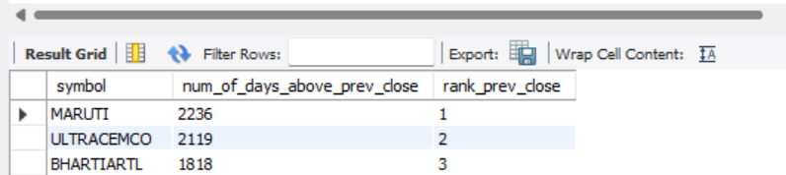

#5. Calculating CAGR( Compound Annual Growth Rate of all 3 stocks)

#A. Bharti Airtel

set @begin_price_bha_artl:=(select close from bharti_airtel where date='2010-01-04');

set @end_price_bha_artl:=(select close from bharti_airtel where date='2021-04-30');

Select @begin_price_bha_artl;

Select @end_price_bha_artl;

set @number_of_years:= (select round(timestampdiff(day,'2010-01-04', '2021-04-30')/365,3));

select round((power((@end_price_bha_artl/@begin_price_bha_artl),(1/@number_of_years) )-1)*100,4) as BHA_ARTL_CAGR;

#A. Maruti Suzuki

set @begin_price_mar_suz:=(select close from maruti_suzuki where date='2010-01-04');

set @end_price_mar_suz:=(select close from maruti_suzuki where date='2021-04-30');

Select @begin_price_mar_suz;

Select @end_price_mar_suz;

set @number_of_years2:= (select round(timestampdiff(day,'2010-01-04', '2021-04-30')/365,3));

select round((power((@end_price_mar_suz/@begin_price_mar_suz),(1/@number_of_years2) )-1)*100,4) as MARUTI_SUZUKI_CAGR;

#C. Ultra Tech Cement

set @begin_price_ult_cem:=(select close from ultra_cemco where date='2010-01-04');

set @end_price_ult_cem:=(select close from ultra_cemco where date='2021-04-30');

Select @begin_price_ult_cem;

Select @end_price_ult_cem;

set @number_of_years3:= (select round(timestampdiff(day,'2010-01-04', '2021-04-30')/365,3));

select round((power((@end_price_ult_cem/@begin_price_ult_cem),(1/@number_of_years3) )-1)*100,4) as ULT_CEM_CAGR;

Output:  
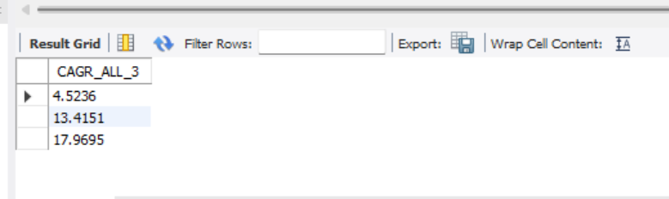

6. Finding Max Volume month of all 3 stocks

Select symbol,year(date) as year, month(date) as month, max(volume) as Max_Vol

from bharti_airtel

group by year(date), month(date), symbol

order by max(volume) desc

limit 1;

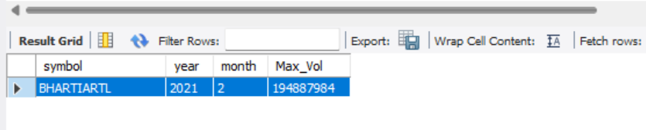

Select symbol,year(date) as year, month(date) as month, max(volume) as Max_Vol

from ultra_cemco

group by year(date), month(date), symbol

order by max(volume) desc

limit 1;

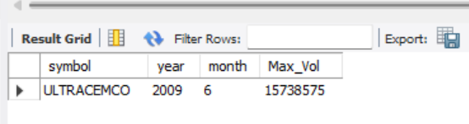

Select symbol,year(date) as year, month(date) as month, max(volume) as Max_Vol

from maruti_suzuki

group by year(date), month(date), symbol

order by max(volume) desc

limit 1;

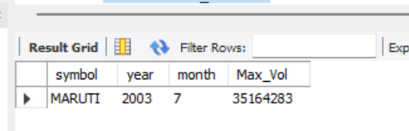

Final Analysis as per above result set:

